6. Research and write what is String pool in java

A String pool is situated in the heap memory also called as string constant pool
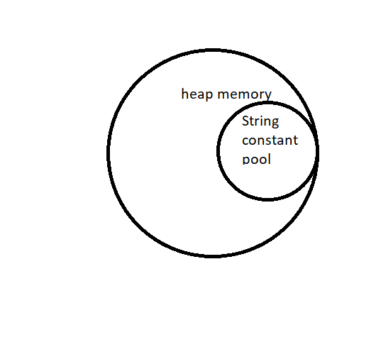
when a string object is created the string value is stored in both the heap memory and the SCP(string constant pool) and the value stored in string contant pool in internally pointed by JVM , hence garbage collection inside SCP wont be done until the scope of the string object ends . when ever a string in created the value in stored in the SCP and not the heap memory.
2 different string object with same string value will return false if compared where as , 2 different string with same value will return true if compared
example: String s1=new String("hello");
String s2= new String("hello");
will return false if compared
whereas, String s1="hello";
String s2="hello";
will return true if compared

